
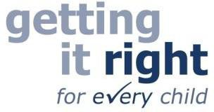
Getting started with Signalong
Information for parents and carers
Signalong is a key word signing system which supports spoken language. It is based on British Sign Language but differs in many ways. It supports individuals with communication difficulties.

To get started with Signalong, please watch our informative video which you can access through the link or QR code below:
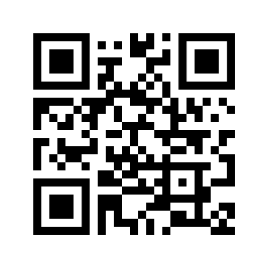

https://vimeo.com/869452845

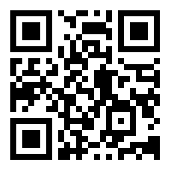
NHS Lothian Speech and Language Therapy team have also created lots of useful videos with a range of vocabulary. You may want to first look at this video with everyday signs before trying some of our topic vocabulary or songs. The link and QR code below will give you everyday signs to get started with.

https://vimeo.com/610521853

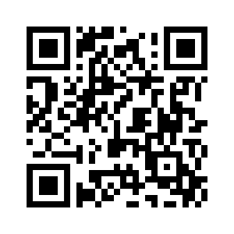
To access more of our Signalong videos you can click on the link or scan the QR code below to take you to our Signalong Vimeo channel.

https://vimeo.com/channels/1635003

Please contact your local Speech and Language Therapist if you require further support.

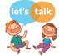 www.lets-talk.scot.nhs.uk

